**Karan Arora**  **R.L. Institute M: 9416974837**

**Max Time : 1 hr** **Class = 12th Biology Test**  **Max Marks : 25**

**BIOTECHNOLOGY AND ITS APPLICATIONS**

1. Multiple choice questions : [ 1 X 5 = 5]
2. In RNAi, gene are silenced by using :

|  |  |  |  |
| --- | --- | --- | --- |
| a) ss DNA | b) ds DNA | c) ds RNA | d) ss RNA |

1. Which one of the following is commonly used in transfer of foreign DNA into crop plants?

|  |  |
| --- | --- |
| a) Meloidogyne incognita | b) Agrobacterium tumefaciens |
| c) Penicillium expansum | d) Tricoderma harzianum |

1. GEAC stands for :

|  |  |
| --- | --- |
| a) Genome Engineering Action Committee | b) Ground Environment Action Committee |
| c) Genetic Engineering Approval Committee | d) Genetic & Environment Approval Committee |

1. $α$- 1 antitrypsin is :

|  |  |
| --- | --- |
| a) an antacid | b) an enzyme |
| c) used to treat arthritis | d) used to treat emphysema |

1. Bio piracy is :

|  |  |
| --- | --- |
| a) use of bio patents | b) thefts of plants and animals |
| c) stealing of bio resources | d) exploitation of bio resources without paying authorization |

1. Define Biopatent. [ 1 ]
2. Define micropropagation. [ 1 ]
3. R-DNA technology is a useful tool for early diagnosis of an infectious diseases. Comment. [ 1 ]
4. Name the first transgenic cow. Which gene was introduced in this cow? [ 1 ]
5. Define Meristem culture. [ 1 ]
6. Which part of the plant is best suited for making virus-free plants and why? [ 1 ]
7. How transgenic animals provide benefits in : [ 2 ]

(a) Vaccine safety (b) Formation of Biological product

1. Describe any 3 potential applications of genetically modified plants. [ 2 ]
2. Find out what the various components of the medium used for propagation of explant in invitro are? [ 2 ]
3. Why do the toxic insecticidal proteins secreted by Bacillus thuringiensis kill the insect and not the bacteria itself? [ 2 ]
4. How has RNAi technique help to prevent the infested of roots in tobacco plant by nematode Meloidogyne incognita? [ 3 ]
5. Refer to the diagram of maturation of proinsulin into insulin to answer the following questions.

[ 3 ]

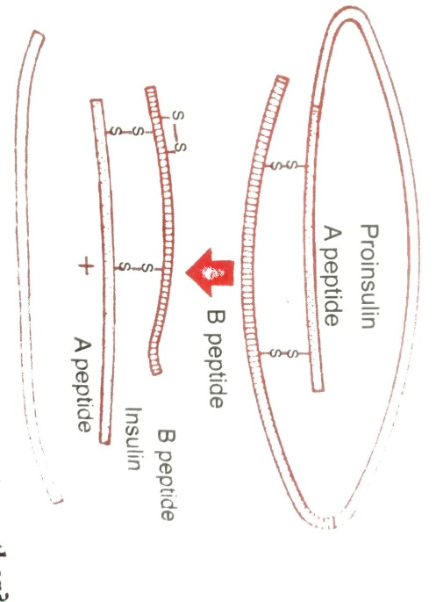

(i) How are two short polypeptide chain of insulin linked together?

(ii) State the role of C-peptide in human insulin.

(iii) Mention the chemical change that proinsulin undergoes, to be able to act as mature insulin